**Module 2: Basic Concepts of Trigonometric Functions**

**V. Transformations of Sine and Cosine Functions**

After completing this section, you should be able to:

* graph transformations of sine and cosine functions

Trigonometric functions such as sine and cosine can be thought of as building blocks for other functions. The graph of a trigonometric function may be transformed by horizontal and vertical translation, reflection, vertical stretching and shrinking, and horizontal stretching and shrinking.

If you are not well acquainted with transformations of functions, it is worth reviewing [module 1, topic III-B](https://umuc.equella.ecollege.com/file/51ed41e5-be80-4110-8171-a40ed58c98af/1/MATH108-0609.zip/Modules/M1-Module_1/S3-Commentary.html#B._Transformations_of_Functions). Use the table of transformations in module 1 as a reference as you consider transformations of sine and cosine.

The ultimate goal of this topic is to graph functions of the forms

*y* = *A* sin(*Bt* – *C*) + *D* and *y* = *A* cos(*Bt* – *C*) + *D*

and to analyze their characteristics.

To get a feel for the transformations of the sine function, start by considering simple functions.

|  |  |
| --- | --- |
| Throughout the following examples, let *f*(*t*) = sin *t*. | https://umuc.equella.ecollege.com/file/51ed41e5-be80-4110-8171-a40ed58c98af/1/MATH108-0609.zip/Modules/M2-Module_2/images/Mod2GraphicsFiles/Mod2-SecV/A-1-sine1period.gif |

**Example V.1:** Graph *g*(*t*) = sin *t* + *D*.

**Solution:**

*g*(*t*) = sin *t*+ *D* = *f*(*t)* + *D*

Each of the *y*-coordinates for *g* equals the sum of the *y*-coordinate for *f* and the constant *D*.

Here are some illustrations:

|  |  |
| --- | --- |
| *D* > 0  https://umuc.equella.ecollege.com/file/51ed41e5-be80-4110-8171-a40ed58c98af/1/MATH108-0609.zip/Modules/M2-Module_2/images/Mod2GraphicsFiles/Mod2-SecV/A-2-shiftup.gif  Shift upward by 0.5. The graph is periodic with period 2π. Amplitude = ½|1.5 – (–0.5)| = 1. | *D* < 0  https://umuc.equella.ecollege.com/file/51ed41e5-be80-4110-8171-a40ed58c98af/1/MATH108-0609.zip/Modules/M2-Module_2/images/Mod2GraphicsFiles/Mod2-SecV/A-3-shiftdown.gif  Shift downward by 2. The graph is periodic with period 2π. Amplitude = ½|–1 – (–3)| = 1. |
| If *D* is positive, the graph of *g* is a shift of the graph of *f*upward by *D* units. If *D* is negative, the graph shifts downward by |*D*| units.  Note that the amplitude and the period of the transformation are the same as those for the original graph. The amplitude is not the maximum *y* value. | |

**Example V.2:** Graph *h*(*t*) = sin(*t* – *C*).

**Solution:**

*h*(*t*) = sin (*t* – *C*) =*f*(*t* – *C*)

If *C* is positive, the graph of *h* is a shift of the graph of *f* to the right by *C* units. If *C* is negative, the graph shifts to the left by |*C*| units. The value *C* is called the *phase shift*. Here are some illustrations:

|  |  |
| --- | --- |
| *C* > 0  https://umuc.equella.ecollege.com/file/51ed41e5-be80-4110-8171-a40ed58c98af/1/MATH108-0609.zip/Modules/M2-Module_2/images/Mod2GraphicsFiles/Mod2-SecV/A-4-shiftright.gif  Shift to the right by π/4. The value π/4 is the phase shift. The graph is periodic with period 2π. Amplitude = 1. | *C* < 0  https://umuc.equella.ecollege.com/file/51ed41e5-be80-4110-8171-a40ed58c98af/1/MATH108-0609.zip/Modules/M2-Module_2/images/Mod2GraphicsFiles/Mod2-SecV/A-5-shiftleft.gif  Shift to the left by π/3. The value –π/3 is the phase shift. The graph is periodic with period 2π. Amplitude = 1. |

Note that the amplitude and the period of the transformation are the same as those for the original sine graph.

**Example V.3:** Graph *p*(*t*) =*A sin t*.

**Solution:**

*p*(*t*) =*A sin t* = *f*(*t*)

Each of the *y*-coordinates for *p* consists of the *y*-coordinate for *f* multiplied by the constant *A*.

Here are some illustrations:

|  |  |
| --- | --- |
| |*A*| > 1 | |*A*| < 1 |
| Vertical stretching by a factor of 3. The graph is periodic with period 2π. Amplitude = ½|3 – (–3)| = 3. | Vertical shrinking by a factor of 0.5. The graph is periodic with period 2π. Amplitude = ½|0.5 – (–0.5)| = ½. |
| *A* < 0    Vertical stretching by a factor of 2 and reflection across the *t*-axis. The graph is periodic with period 2π. Amplitude = ½|2 – (–2)| = 2.  **Summary:**  If |*A*| > 1, the graph is stretched vertically. If |*A*| < 1, then the graph shrinks vertically. If *A* < 0, the graph is reflected across the *t*-axis. The amplitude of the graph of *A* sin *t* is |*A*|. The period is unchanged. | |

|  |  |  |
| --- | --- | --- |
| **Example V.4:** Graph *q*(*t*) = sin *Bt*.  **Solution:**  *q*(*t*) = sin *Bt*= *f*(*Bt*)  The graph of *q* is a horizontal stretching/shrinking of the graph of *f* by a factor |*B*|. If *B* is negative, the graph is reflected across the *y*-axis.  Here are some illustrations:   |  |  | | --- | --- | | |*B*| > 1    The graph of *y* = sin 2*t* is a horizontal shrinking by a factor of 2; it oscillates more rapidly than *y* = sin *t*. One cycle is illustrated in blue.  Period = 2π/2 = π. | |*B*| < 1    The graph of *y*= sin [(1/3)*t*] is a horizontal stretching; it oscillates more slowly than *y*= sin *t*. The graph completes one cycle between –3π and 3π.  Period = 2π/(1/3) = 6π. | |
| |*B*| > 1 and *B* < 0    The graph of *y*= sin 4*t* is a horizontal shrinking of *y*= sin *t* by a factor of 4; thus, the graph oscillates 4 times as fast as sin *t*. The graph of *y*= sin(–4*t*) is a reflection of the graph of *y*= sin 4*t* across the *y*-axis. In other words, since the sine function is odd, *y*= sin(–4*t*) = –sin(4*t*). One cycle is illustrated in blue.  Period = 2π/4 = π/2.  **Summary:**  If |*B*| > 1, the function oscillates more rapidly than the graph of the original function. If |*B*| < 1, the function oscillates more slowly. If *B* is negative, the graph is reflected across the *y*-axis. The amplitude remains the same. The period of the transformation is 2π/|*B*|. |

Now consider several more complicated examples which involve a sequence of transformations.

**Example V.5:** Graph the function *g*(*t*) = 2 sin 3*t* – 1.

**Solution:**

The idea is to start with *f*(*t*) = sin *t* and arrive at *g*(*t*) via a sequence of transformations.

Notice that *g*(*t*) = 2 *f*(3*t*) – 1.

The graph of *y* = *f*(3*t*) = sin 3*t* is a horizontal shrinking of the graph of the sine function by a factor of 3. The resulting function has amplitude 1 and period 2π/3.

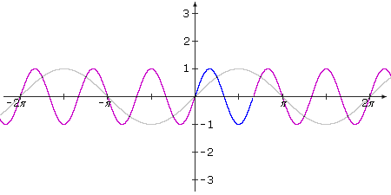

Next, find the graph of *y* = 2 *f*(3*t*) = 2 sin 3*t*. Take the graph of *y*= sin 3*t* and stretch it vertically by a factor of 2. The new graph has amplitude 2 and period 2π/3.

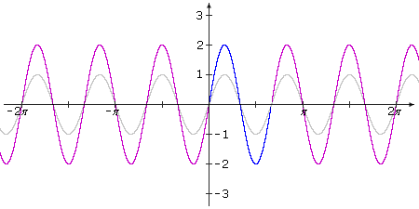

Lastly, determine the graph of *y* = 2 *f*(3*t*) – 1 = 2 sin 3*t* – 1. Take the previous graph and shift it downward by 1 unit. The final graph still has amplitude 2 and period 2π/3.

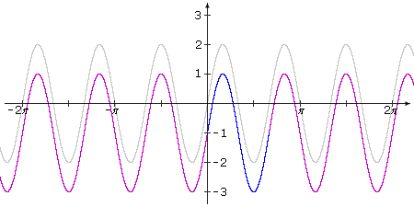

**Example V.6:** Graph the function *h*(*t*) = sin(4*t* – π).

**Solution:**

This function is complicated to graph because it involves two transformations in the horizontal direction: a horizontal shrinking and a horizontal shift.

Because the function *f*(*t*) = sin *t* completes one cycle for 0 ≤ *t* ≤ 2π, we know that

*h*(*t*) = sin(4*t* – π) completes one cycle for 0 ≤ 4*t* – π ≤ 2π.

|  |  |
| --- | --- |
| Solve for *t*: | 0 ≤ 4*t* – π ≤ 2π π ≤ 4*t* ≤ 3π  π/4 ≤ *t* ≤ 3π/4 |

The period is 3π/4 – π/4 = 2π/4 = π/2.

Since the cycle starts at π/4 rather than 0, there is a horizontal shift to the right by π/4.

These facts can also be determined as a result of manipulating the formula for the function.

Notice that *h*(*t*) = sin(4*t* – π) = sin[4(*t* – π/4)].

Due to the factor of 4 in sin[4(*t* – π/4)], the period shrinks by a factor of 4 to 2π/4 = π/2.

The expression (*t* – π/4) indicates that there is a phase shift of π/4.

Perform the horizontal shrinking first to get

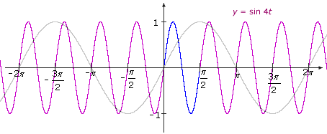

Then shift to the right by π/4:

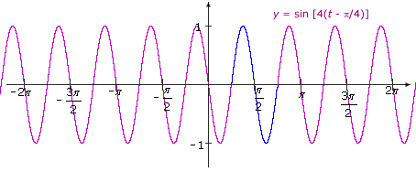

The final graph has amplitude 1, period π/2, and phase shift π/4.

You now have all of the knowledge necessary to graph functions of the form *y*= *A* sin(*Bt* – *C*) + *D*.

In preparing a graph, be careful to first write the expression in the form *y*= *A* sin[*B*(*t* – *C*/*B*)] + *D*.

**Graphing Functions of the Form *y* = *A* sin[*B*(*t* – *C*/*B*)] + *D***

To graph the function *y* = *A* sin[*B*(*t* – *C*/*B*)] + *D*, perform the following steps in the order given:

1. Stretch/shrink the graph of *y*= sin *t* horizontally to get the graph of *y*= sin *Bt*. The new graph has period 2π/|*B*|. If *B* < 0, also reflect the graph across the *y*-axis.
2. Shift the graph of *y*= sin *Bt* horizontally by *C*/*B* to get the graph of *y*= sin[*B*(*t* – *C*/*B*)]. The new graph has phase shift *C*/*B*.
3. Stretch/shrink the graph of *y*= sin[*B*(*t* – *C*/*B*)] vertically to get the graph of *y*= A sin[*B*(*t* – *C*/*B*)]. If *A* < 0, also reflect the graph across the *t*-axis. The new graph has amplitude |*A*|.
4. Shift the graph of *y*= *A* sin[*B*(*t* – *C*/*B*)] vertically to get the graph of *y*= *A* sin[*B*(*t* – *C*/*B*)] + *D*.

The resulting graph is a transformed graph of *y*= sin *t*, having amplitude |*A*|, period 2π/|*B*| and phase shift *C*/*B*.

The same steps apply for graphing a function of the form *y*= *A* cos(*Bt* – *C*) + *D*.

[*Return to top of page*](https://umuc.equella.ecollege.com/file/51ed41e5-be80-4110-8171-a40ed58c98af/1/Transformations%20of%20Sine%20and%20Cosine%20Functions.html#pagetop)

[**Report broken links or any other problems on this page.**](http://help.umuc.edu/)  
  
[**Copyright © by University of Maryland University College.**](https://umuc.equella.ecollege.com/file/51ed41e5-be80-4110-8171-a40ed58c98af/1/MATH108-0609.zip/common/copyright.html)